Prism-Based Composite Solids Formed by Addition

Definition
# Source: AI Source: Provided by: [Data Path: Persons Table -> ID Column: 1, Name_En Column: Motasem Essam] -> From: [ChatGPT] on [7/25/2026]
Prism-based composite solids are three-dimensional geometric objects formed by joining two or more prisms to create a single, larger solid.
The prisms may have identical or different cross-sectional shapes, dimensions, and heights. They can be joined along their faces, bases, or lateral surfaces to produce various composite structures.
Common prism components include triangular prisms, rectangular prisms, square prisms, pentagonal prisms, and hexagonal prisms.
Examples include:
- Two rectangular prisms joined side by side.
- A rectangular prism joined to a triangular prism.
- Multiple rectangular prisms arranged in a stepped structure.
- Two triangular prisms joined along a lateral face.
- A composite solid formed by combining rectangular and pentagonal prisms.

Simple Definition
# Source: AI Source: Provided by: [Data Path: Persons Table -> ID Column: 1, Name_En Column: Motasem Essam] -> From: [ChatGPT] on [7/25/2026]
A prism-based composite solid is a 3D shape created by joining two or more prisms together.
Its total volume is calculated by adding the volumes of its components, while its external surface area includes only the exposed surfaces.

Geometric Representation
# Source: AI Source: Provided by: [Data Path: Persons Table -> ID Column: 1, Name_En Column: Motasem Essam] -> From: [ChatGPT] on [7/25/2026]
A prism-based composite solid consists of several geometric elements:
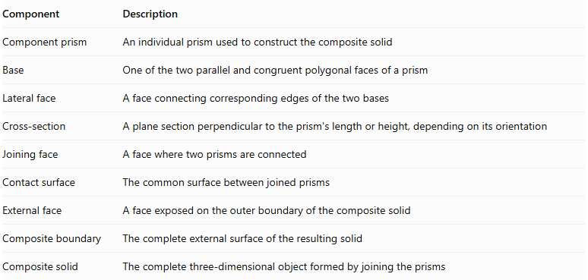
Component | Description
Component prism | An individual prism used to construct the composite solid
Base | One of the two parallel and congruent polygonal faces of a prism
Lateral face | A face connecting corresponding edges of the two bases
Cross-section | A plane section perpendicular to the prism's length or height, depending on its orientation
Joining face | A face where two prisms are connected
Contact surface | The common surface between joined prisms
External face | A face exposed on the outer boundary of the composite solid
Composite boundary | The complete external surface of the resulting solid
Composite solid | The complete three-dimensional object formed by joining the prisms

Types of Prism-Based Composite Solids
# Source: AI Source: Provided by: [Data Path: Persons Table -> ID Column: 1, Name_En Column: Motasem Essam] -> From: [ChatGPT] on [7/25/2026]
These solids can be classified according to the geometric shapes of their component prisms.

Rectangular Prism-Based Composite Solids
# Source: AI Source: Provided by: [Data Path: Persons Table -> ID Column: 1, Name_En Column: Motasem Essam] -> From: [ChatGPT] on [7/25/2026]
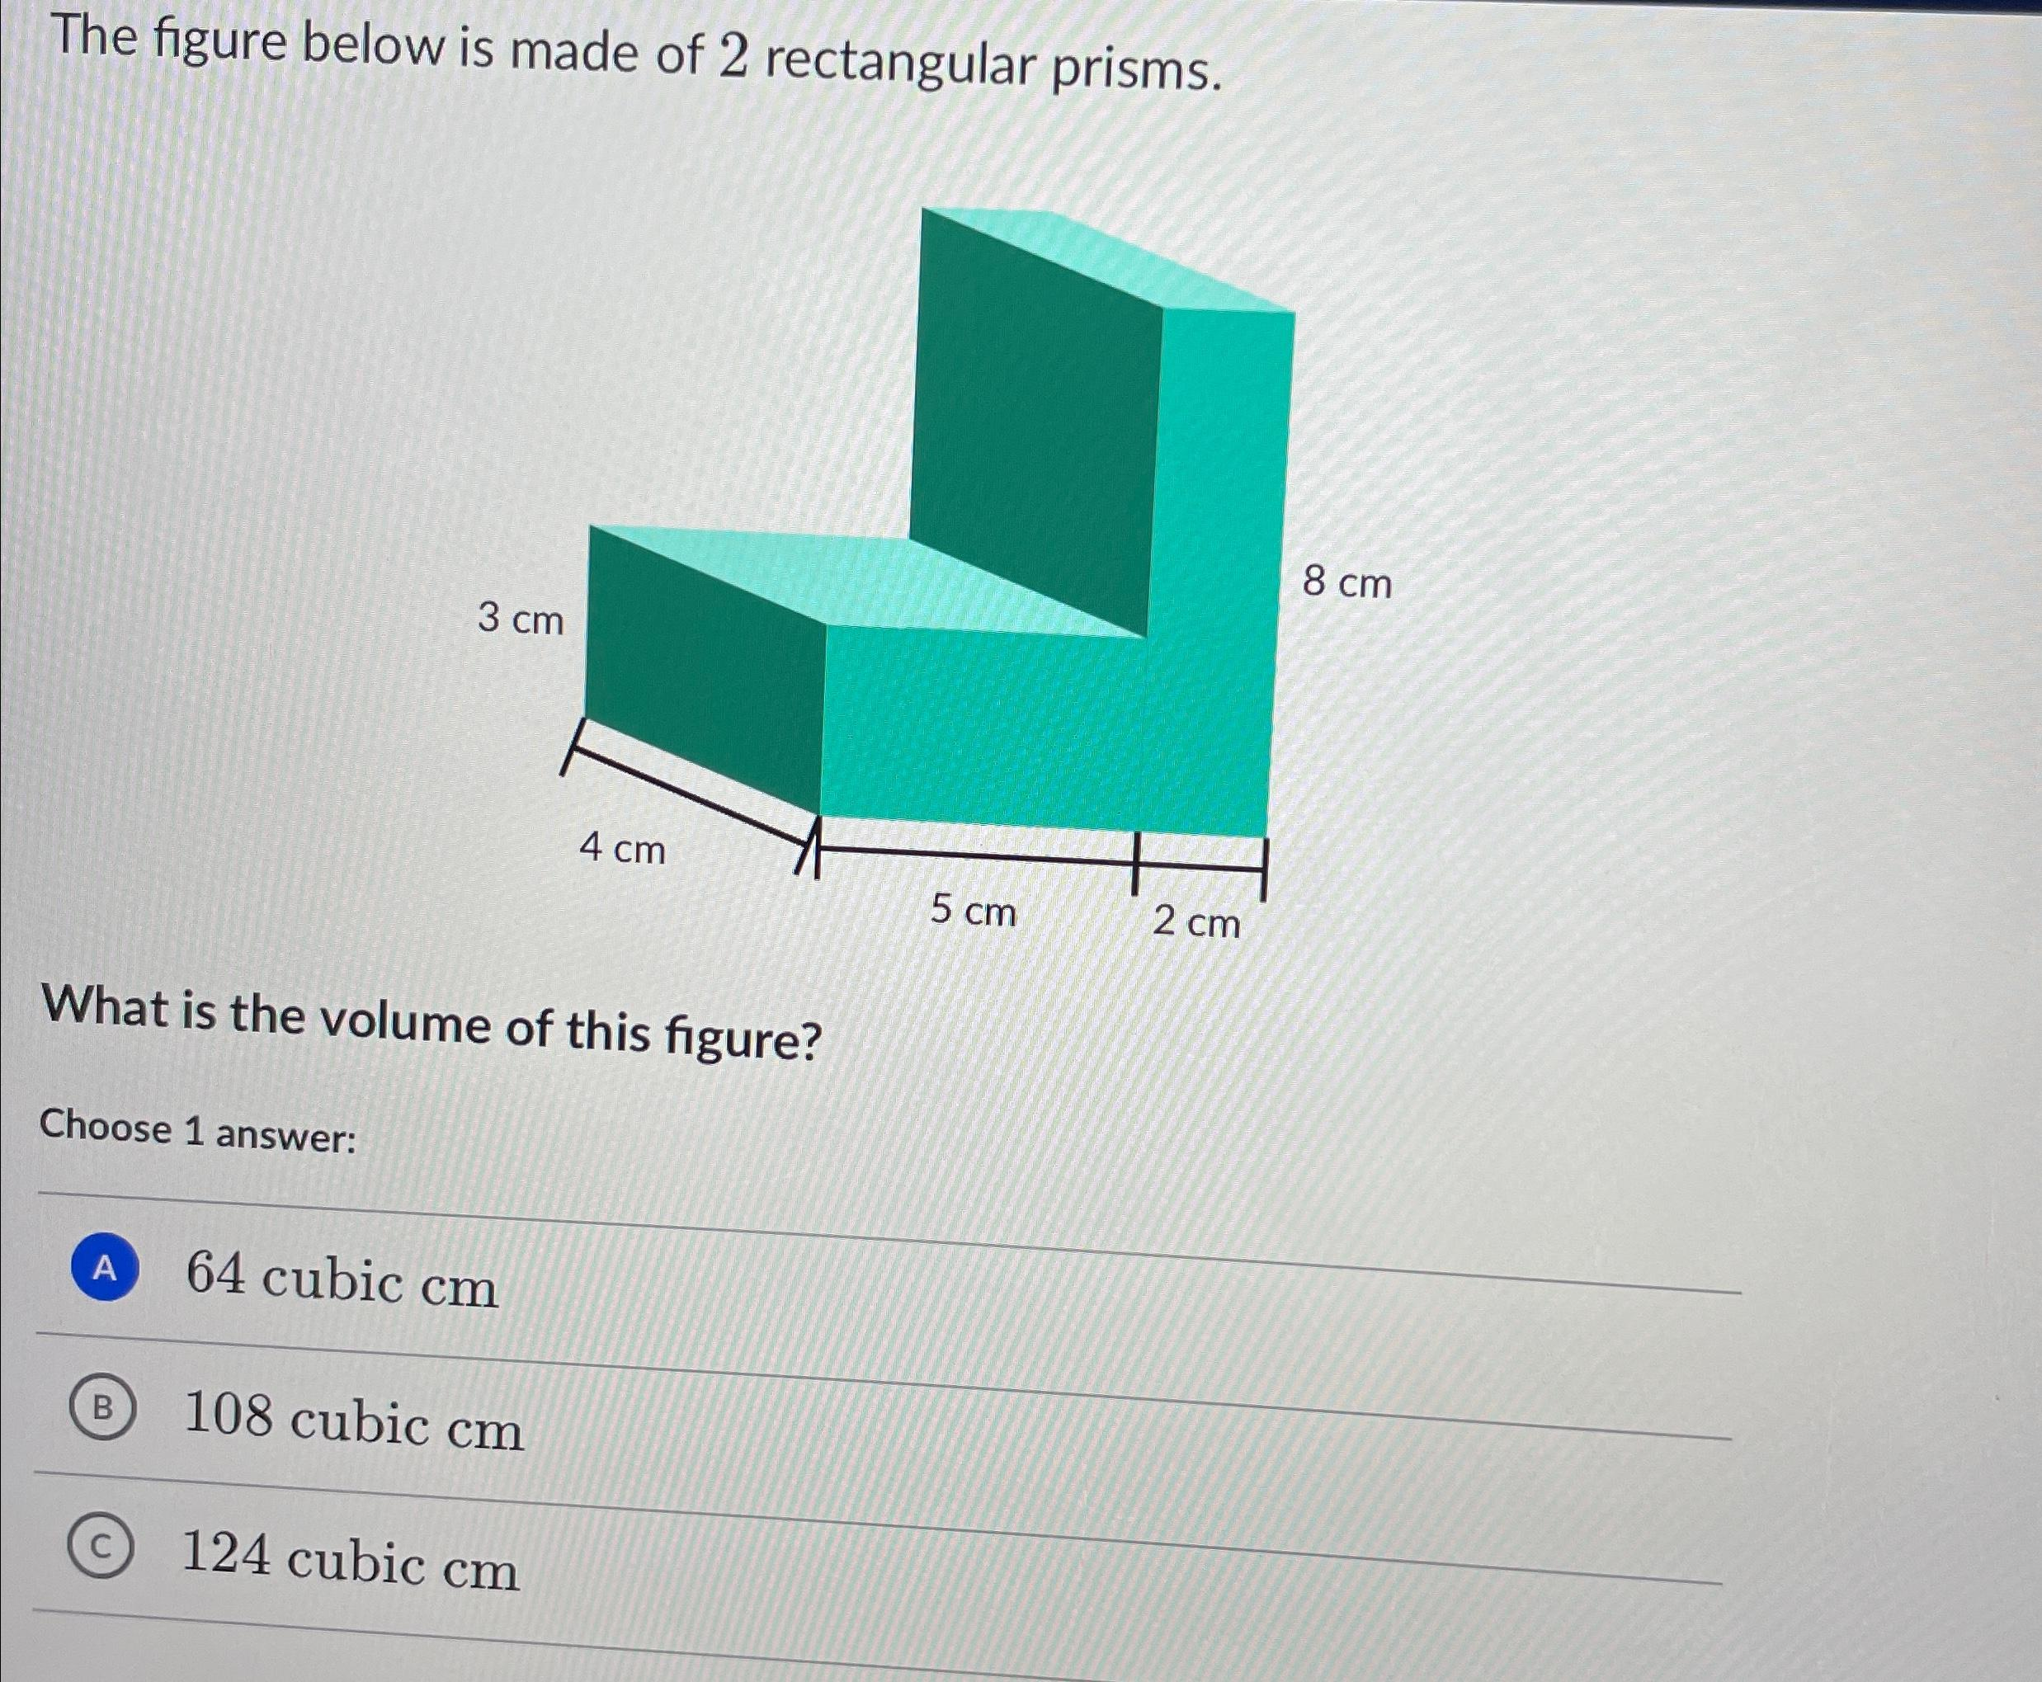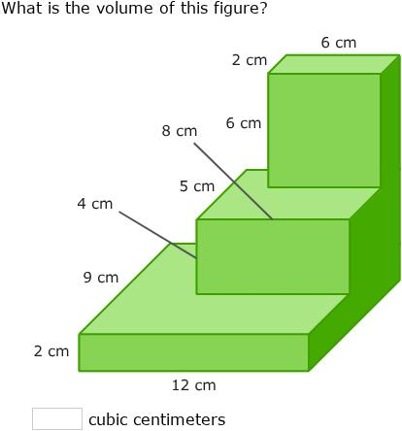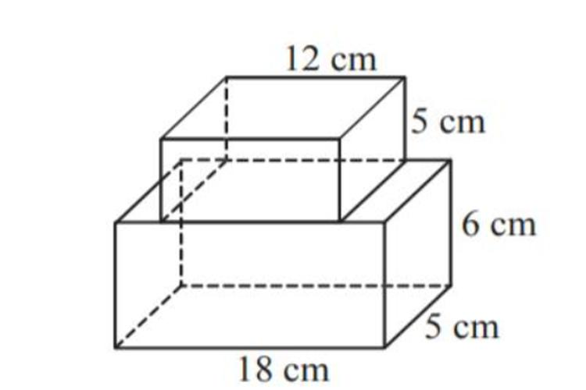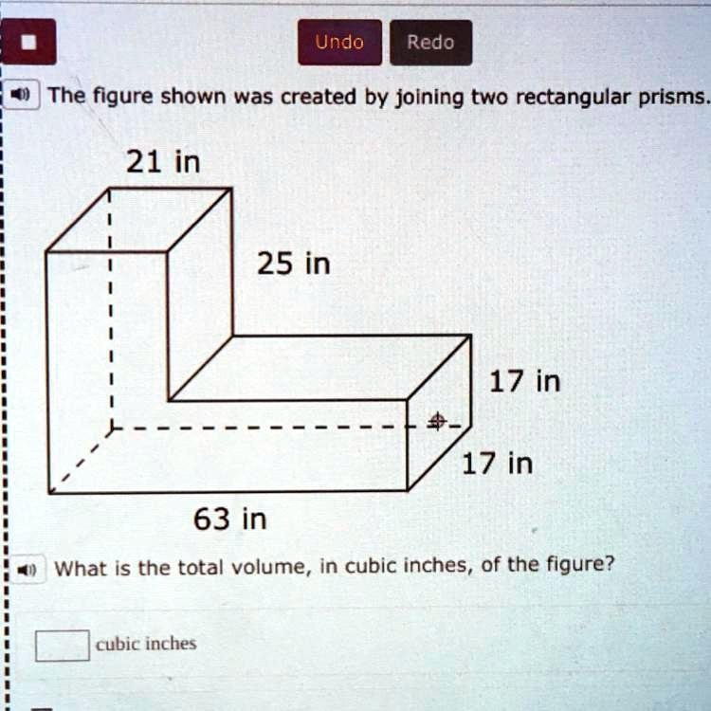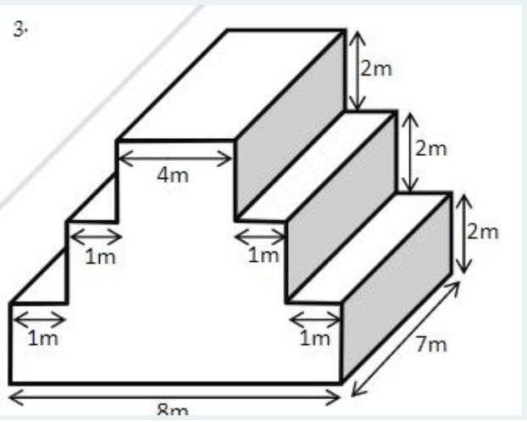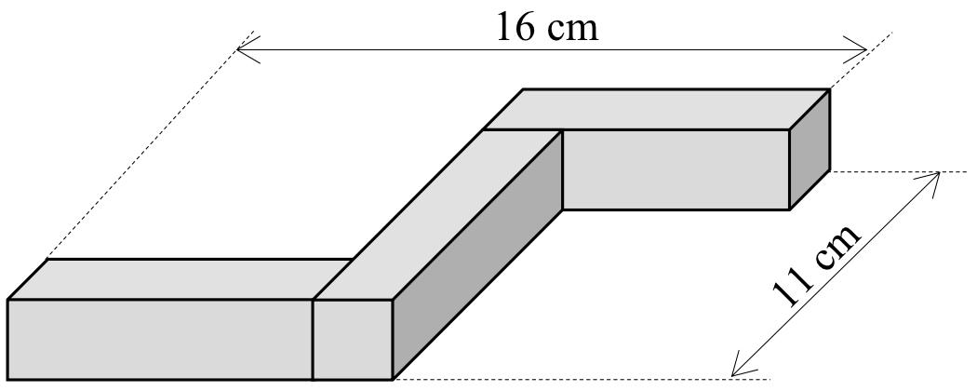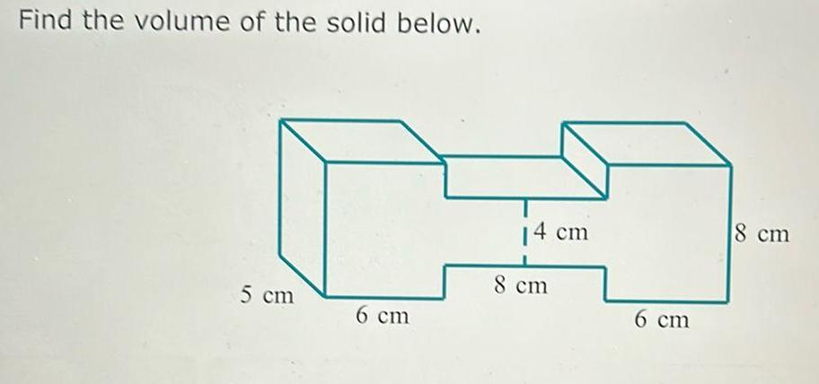
Created by joining two or more rectangular prisms to form a larger geometric solid.
Examples:
- Two rectangular prisms joined side by side.
- Rectangular prisms stacked vertically.
- Stepped solid formed by joining rectangular prisms.
- L-shaped composite solid formed by rectangular prisms.
- T-shaped composite solid formed by rectangular prisms.
- Cross-shaped composite solid formed by rectangular prisms.
- Composite solid formed by joining rectangular prisms of different dimensions.

Triangular Prism-Based Composite Solids
# Source: AI Source: Provided by: [Data Path: Persons Table -> ID Column: 1, Name_En Column: Motasem Essam] -> From: [ChatGPT] on [7/25/2026]
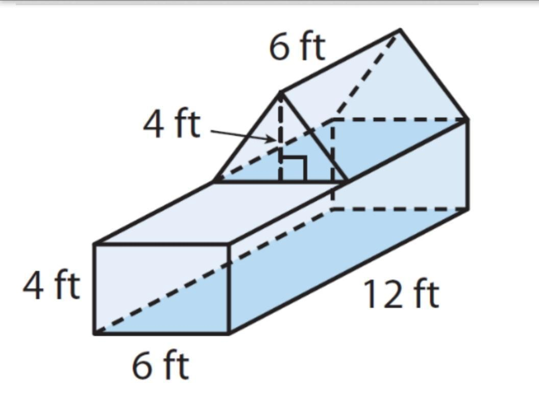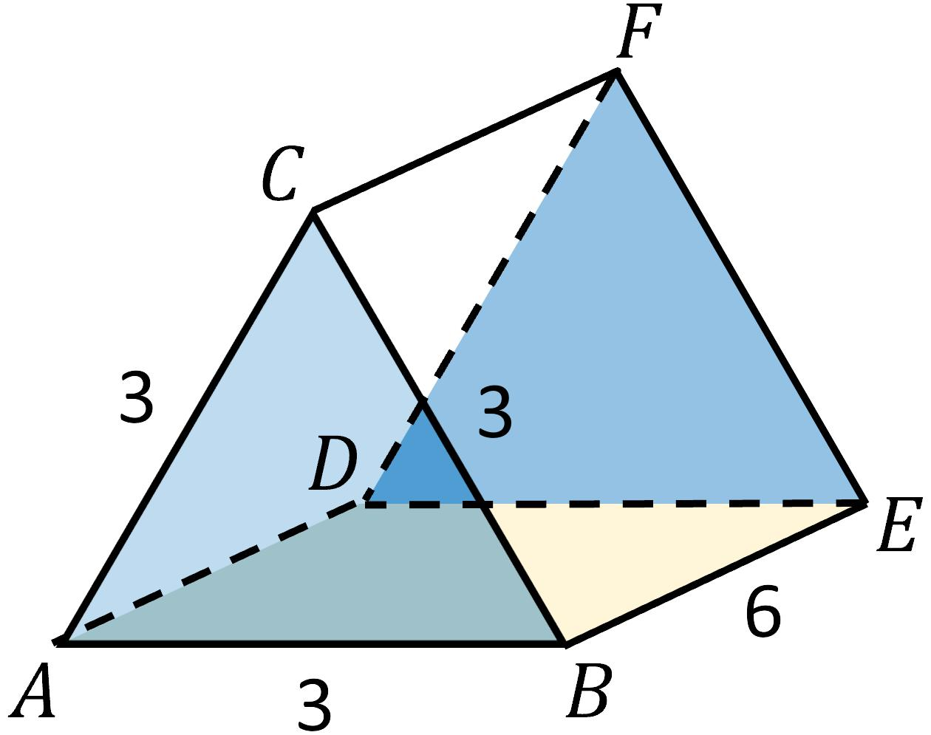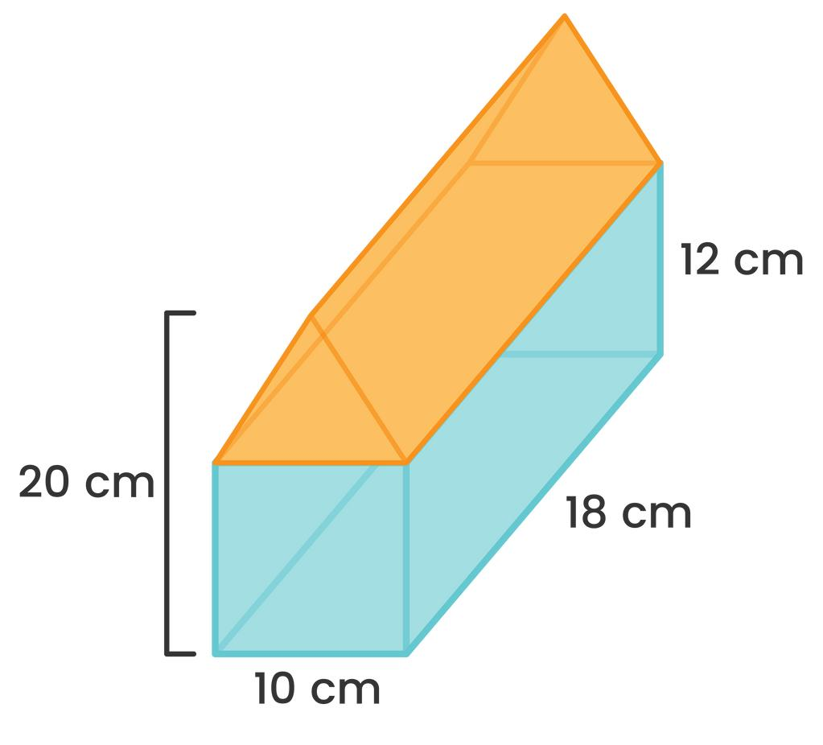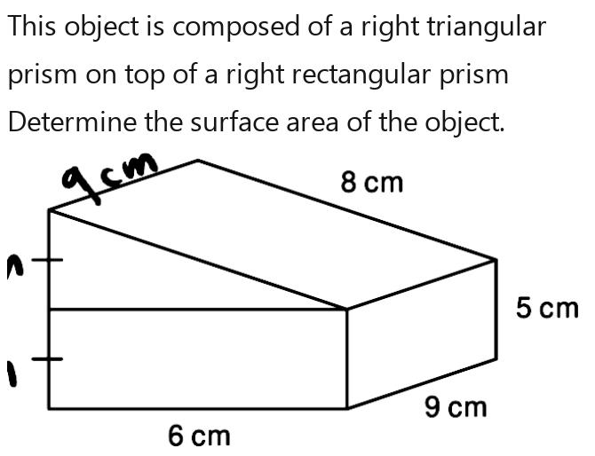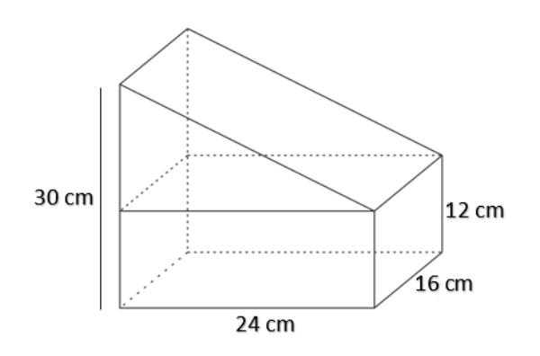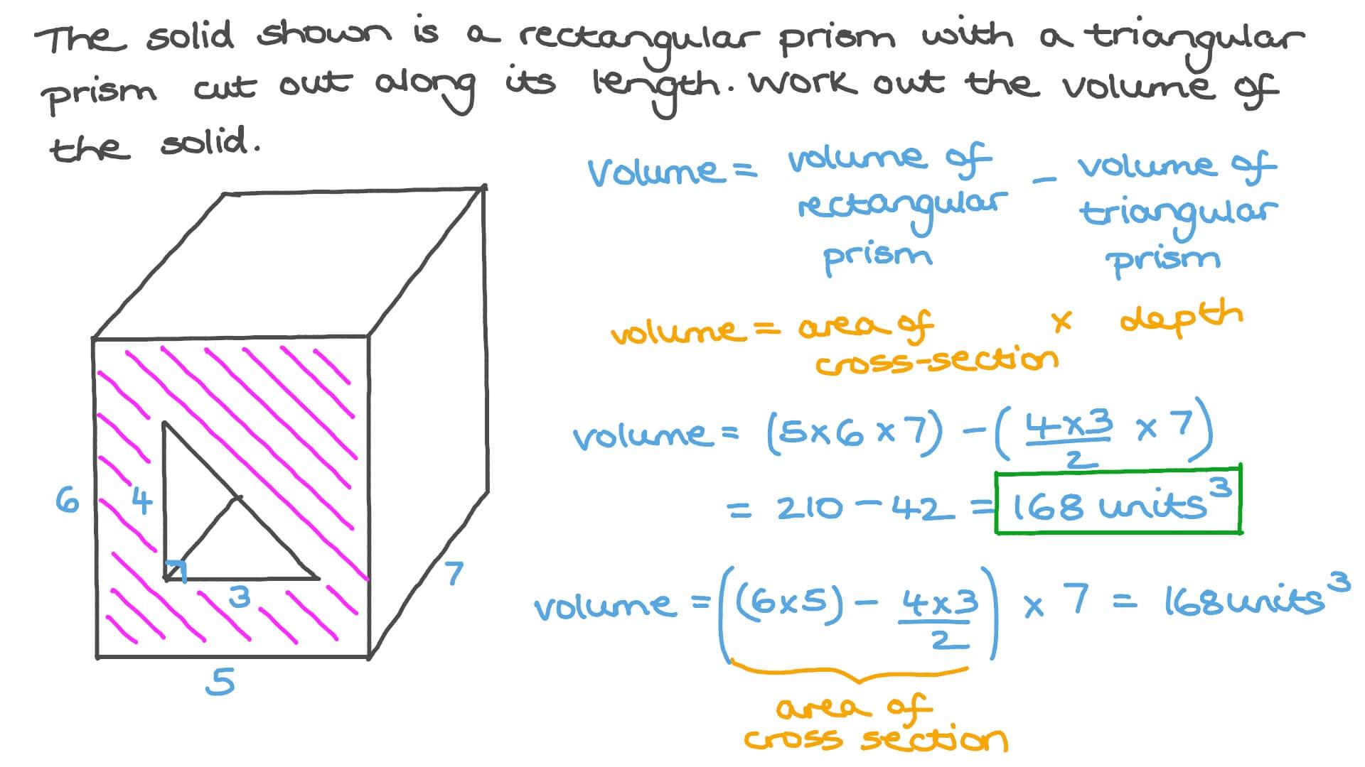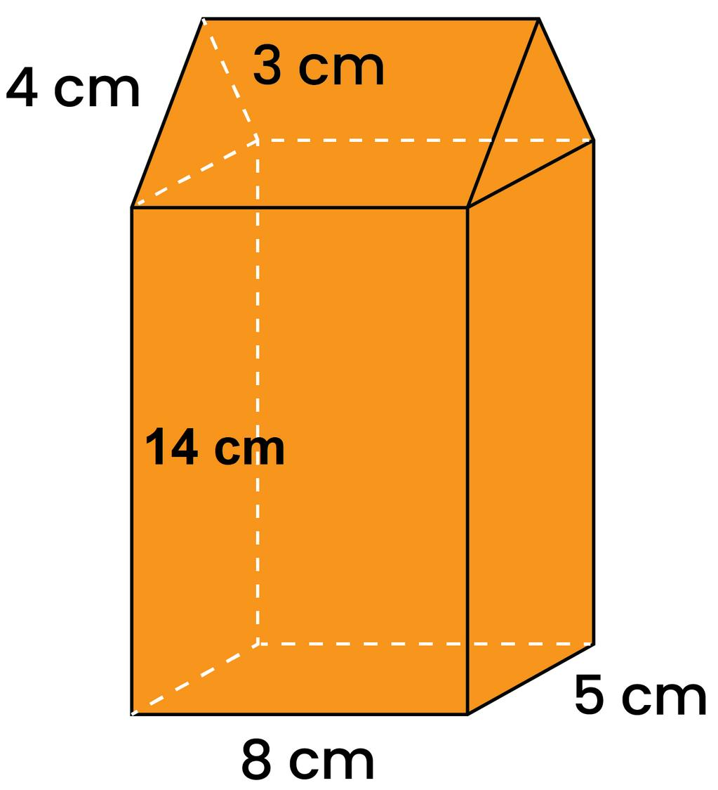
Created by joining two or more triangular prisms.
Examples:
- Two triangular prisms joined along a lateral face.
- Two triangular prisms joined at their triangular bases.
- Rectangular prism combined with a triangular prism.
- Composite solid formed by stacking triangular prisms.
- Multiple triangular prisms arranged side by side.
- Composite solid formed by joining triangular prisms of different dimensions.

Square Prism-Based Composite Solids
# Source: AI Source: Provided by: [Data Path: Persons Table -> ID Column: 1, Name_En Column: Motasem Essam] -> From: [ChatGPT] on [7/25/2026]
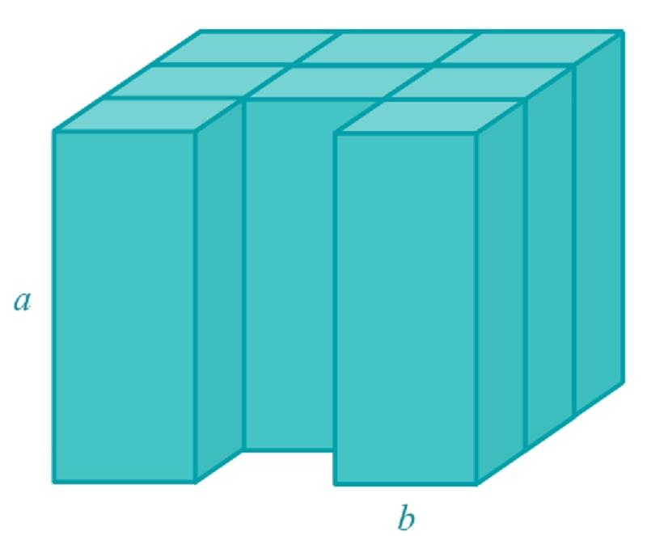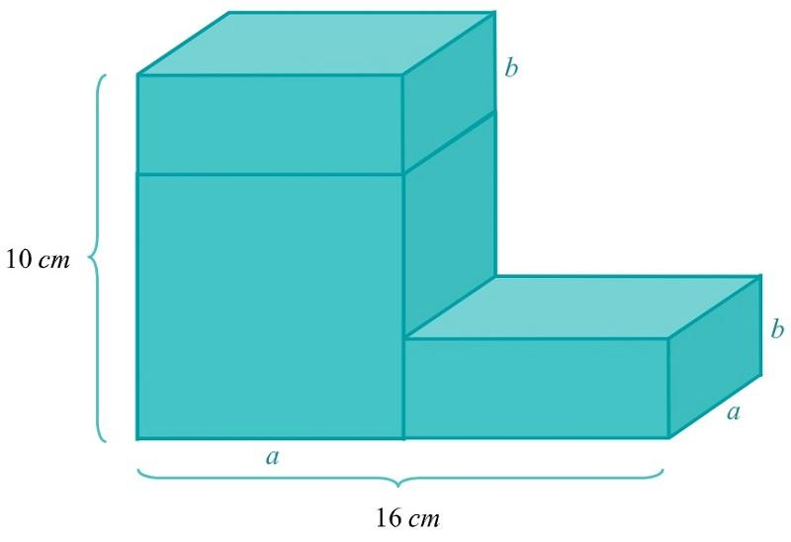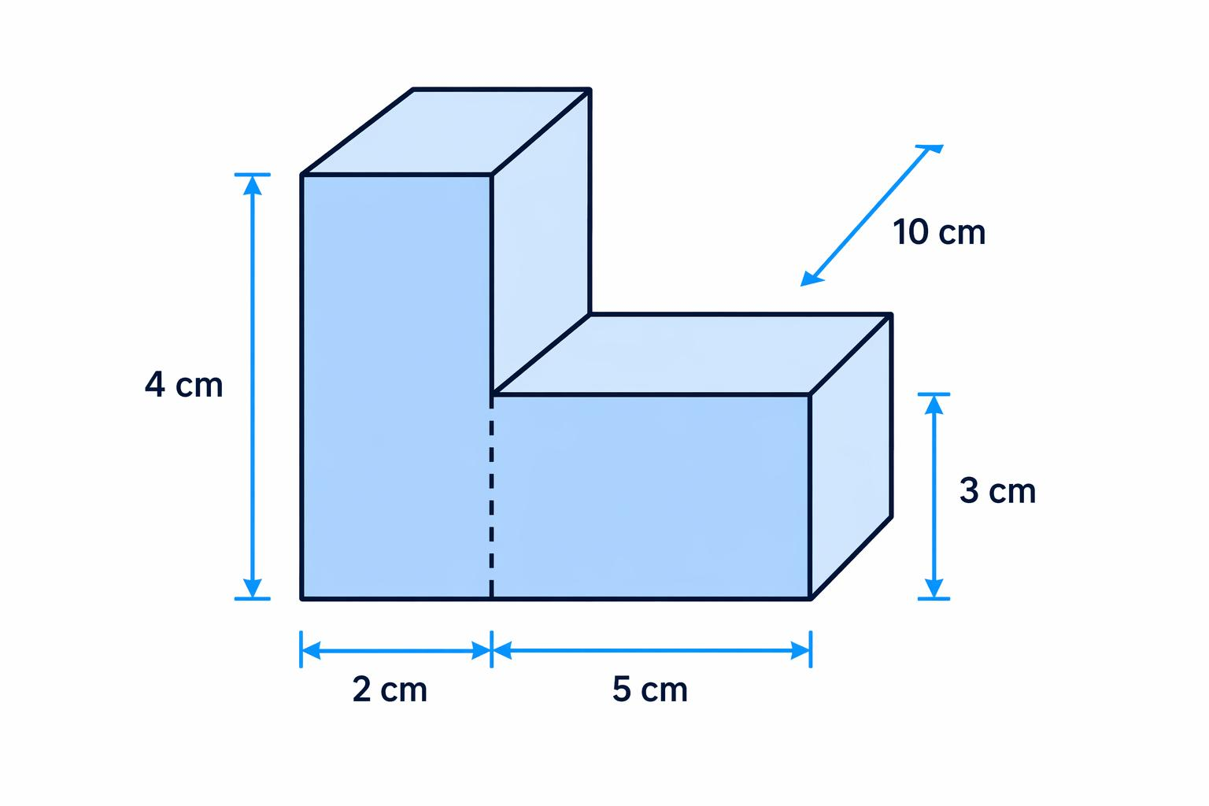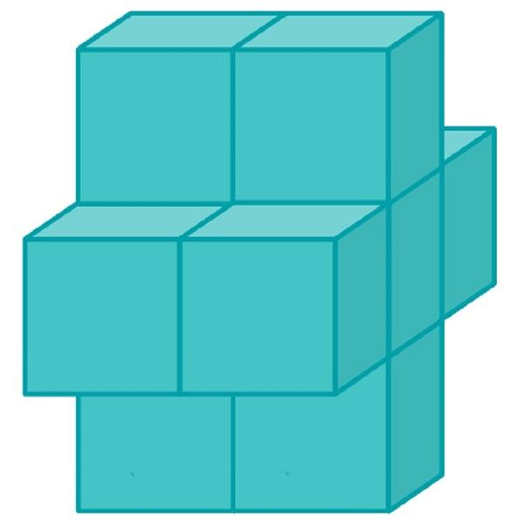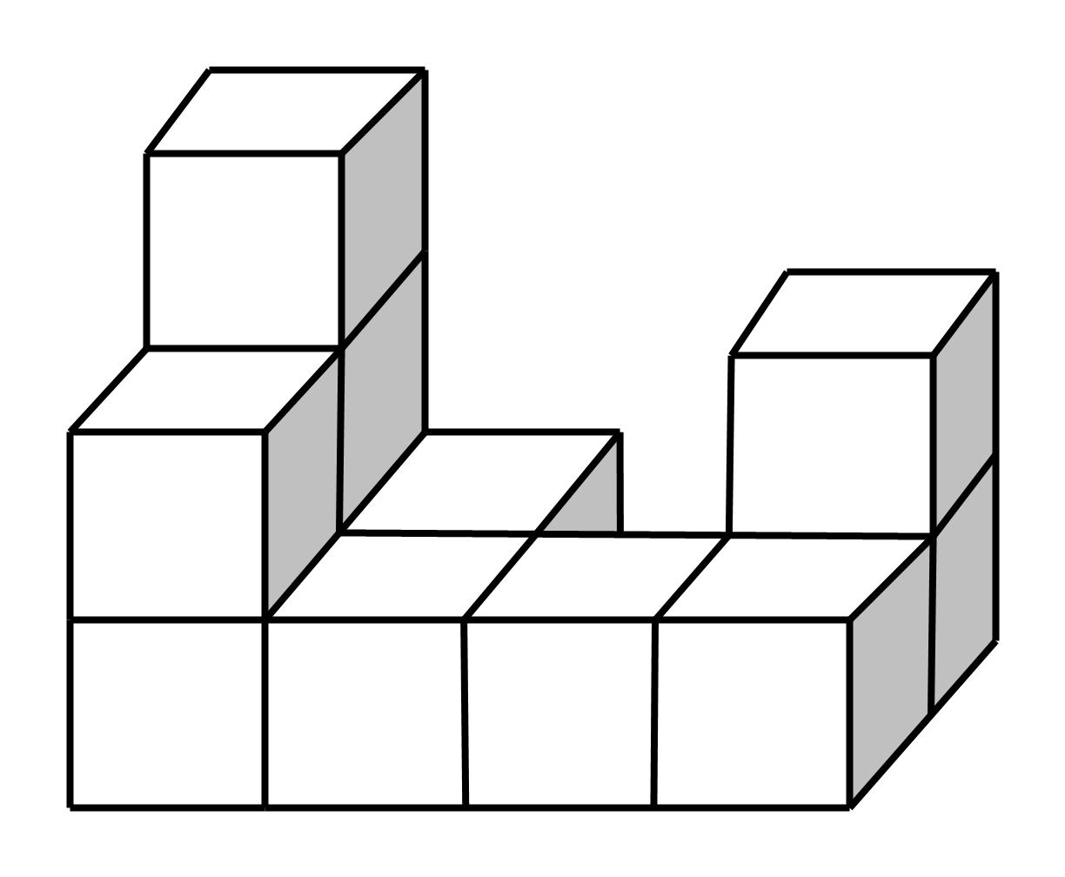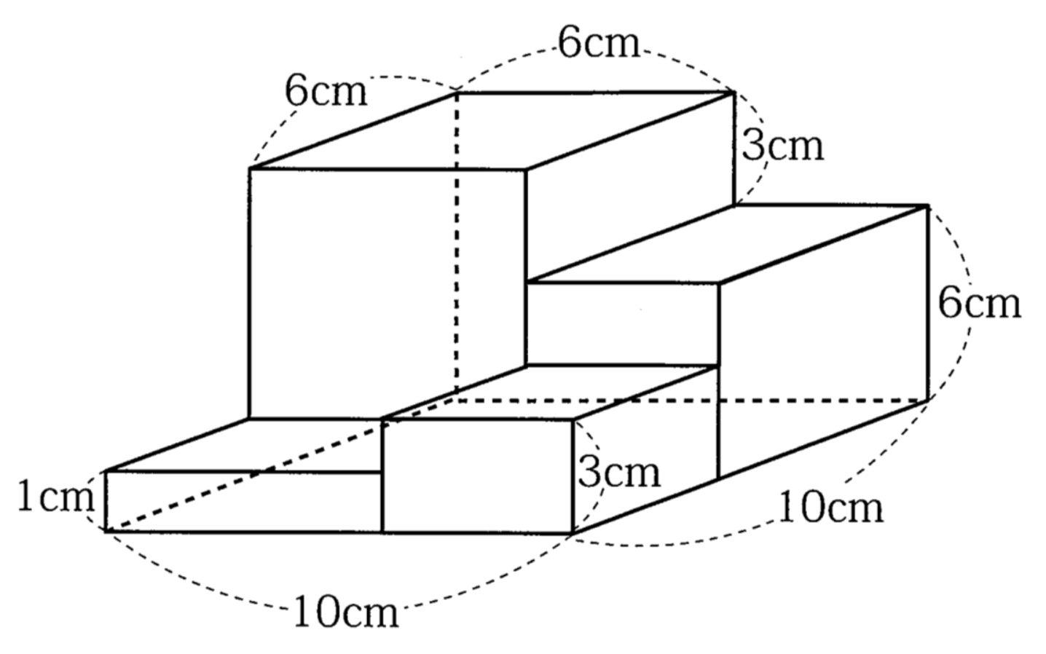
Created by joining multiple square prisms.
Examples:
- Two square prisms joined end to end.
- Square prisms stacked vertically.
- Composite solid formed by joining square prisms side by side.
- Stepped structure made of square prisms.
- Cross-shaped arrangement of square prisms.
- Composite solid formed by square prisms of different dimensions.

Pentagonal Prism-Based Composite Solids
# Source: AI Source: Provided by: [Data Path: Persons Table -> ID Column: 1, Name_En Column: Motasem Essam] -> From: [ChatGPT] on [7/25/2026]
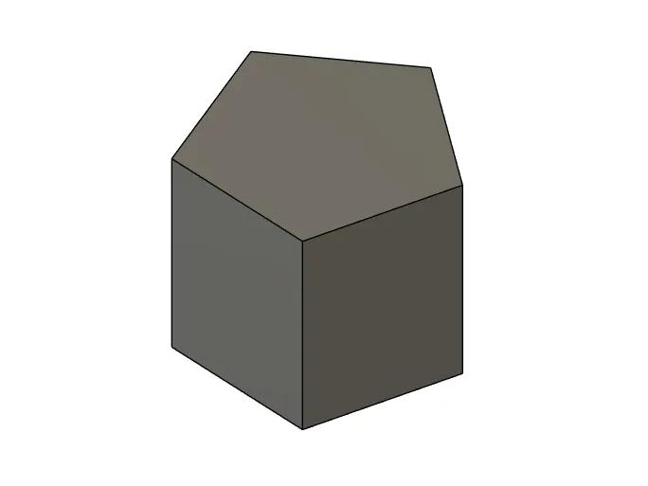
Created by joining two or more pentagonal prisms.
Examples:
- Two pentagonal prisms joined along a lateral face.
- Pentagonal prism combined with a rectangular prism.
- Multiple pentagonal prisms joined end to end.
- Pentagonal prism connected to a triangular prism.
- Composite solid formed by joining pentagonal prisms of different dimensions.

Hexagonal Prism-Based Composite Solids
# Source: AI Source: Provided by: [Data Path: Persons Table -> ID Column: 1, Name_En Column: Motasem Essam] -> From: [ChatGPT] on [7/25/2026]
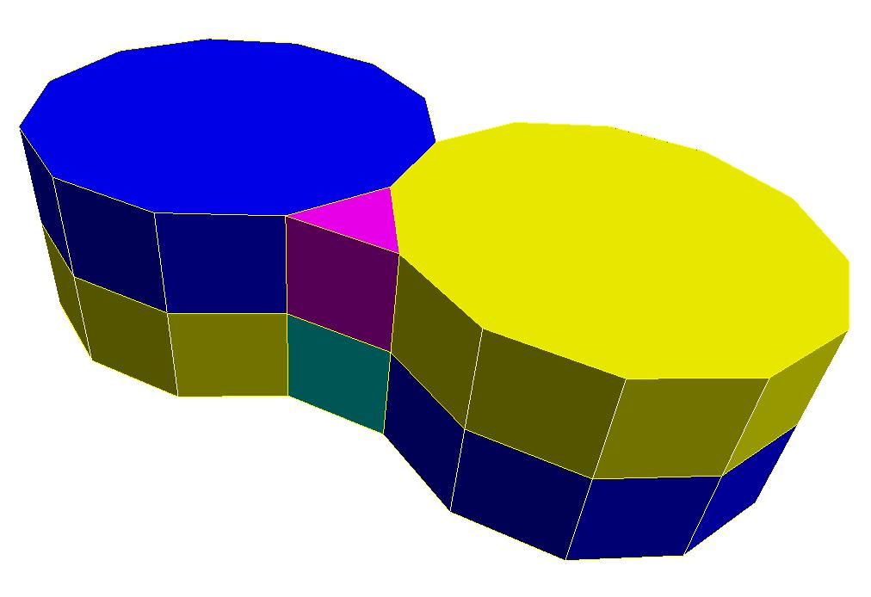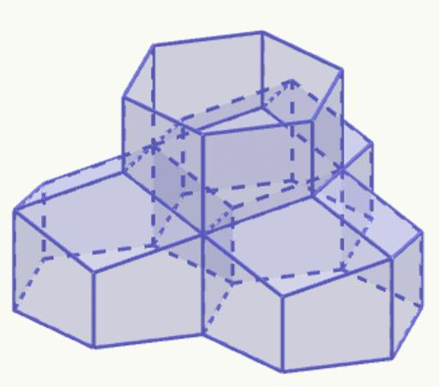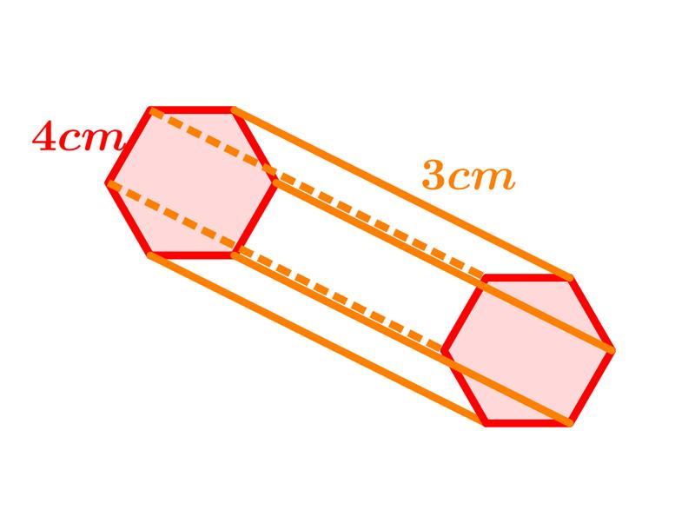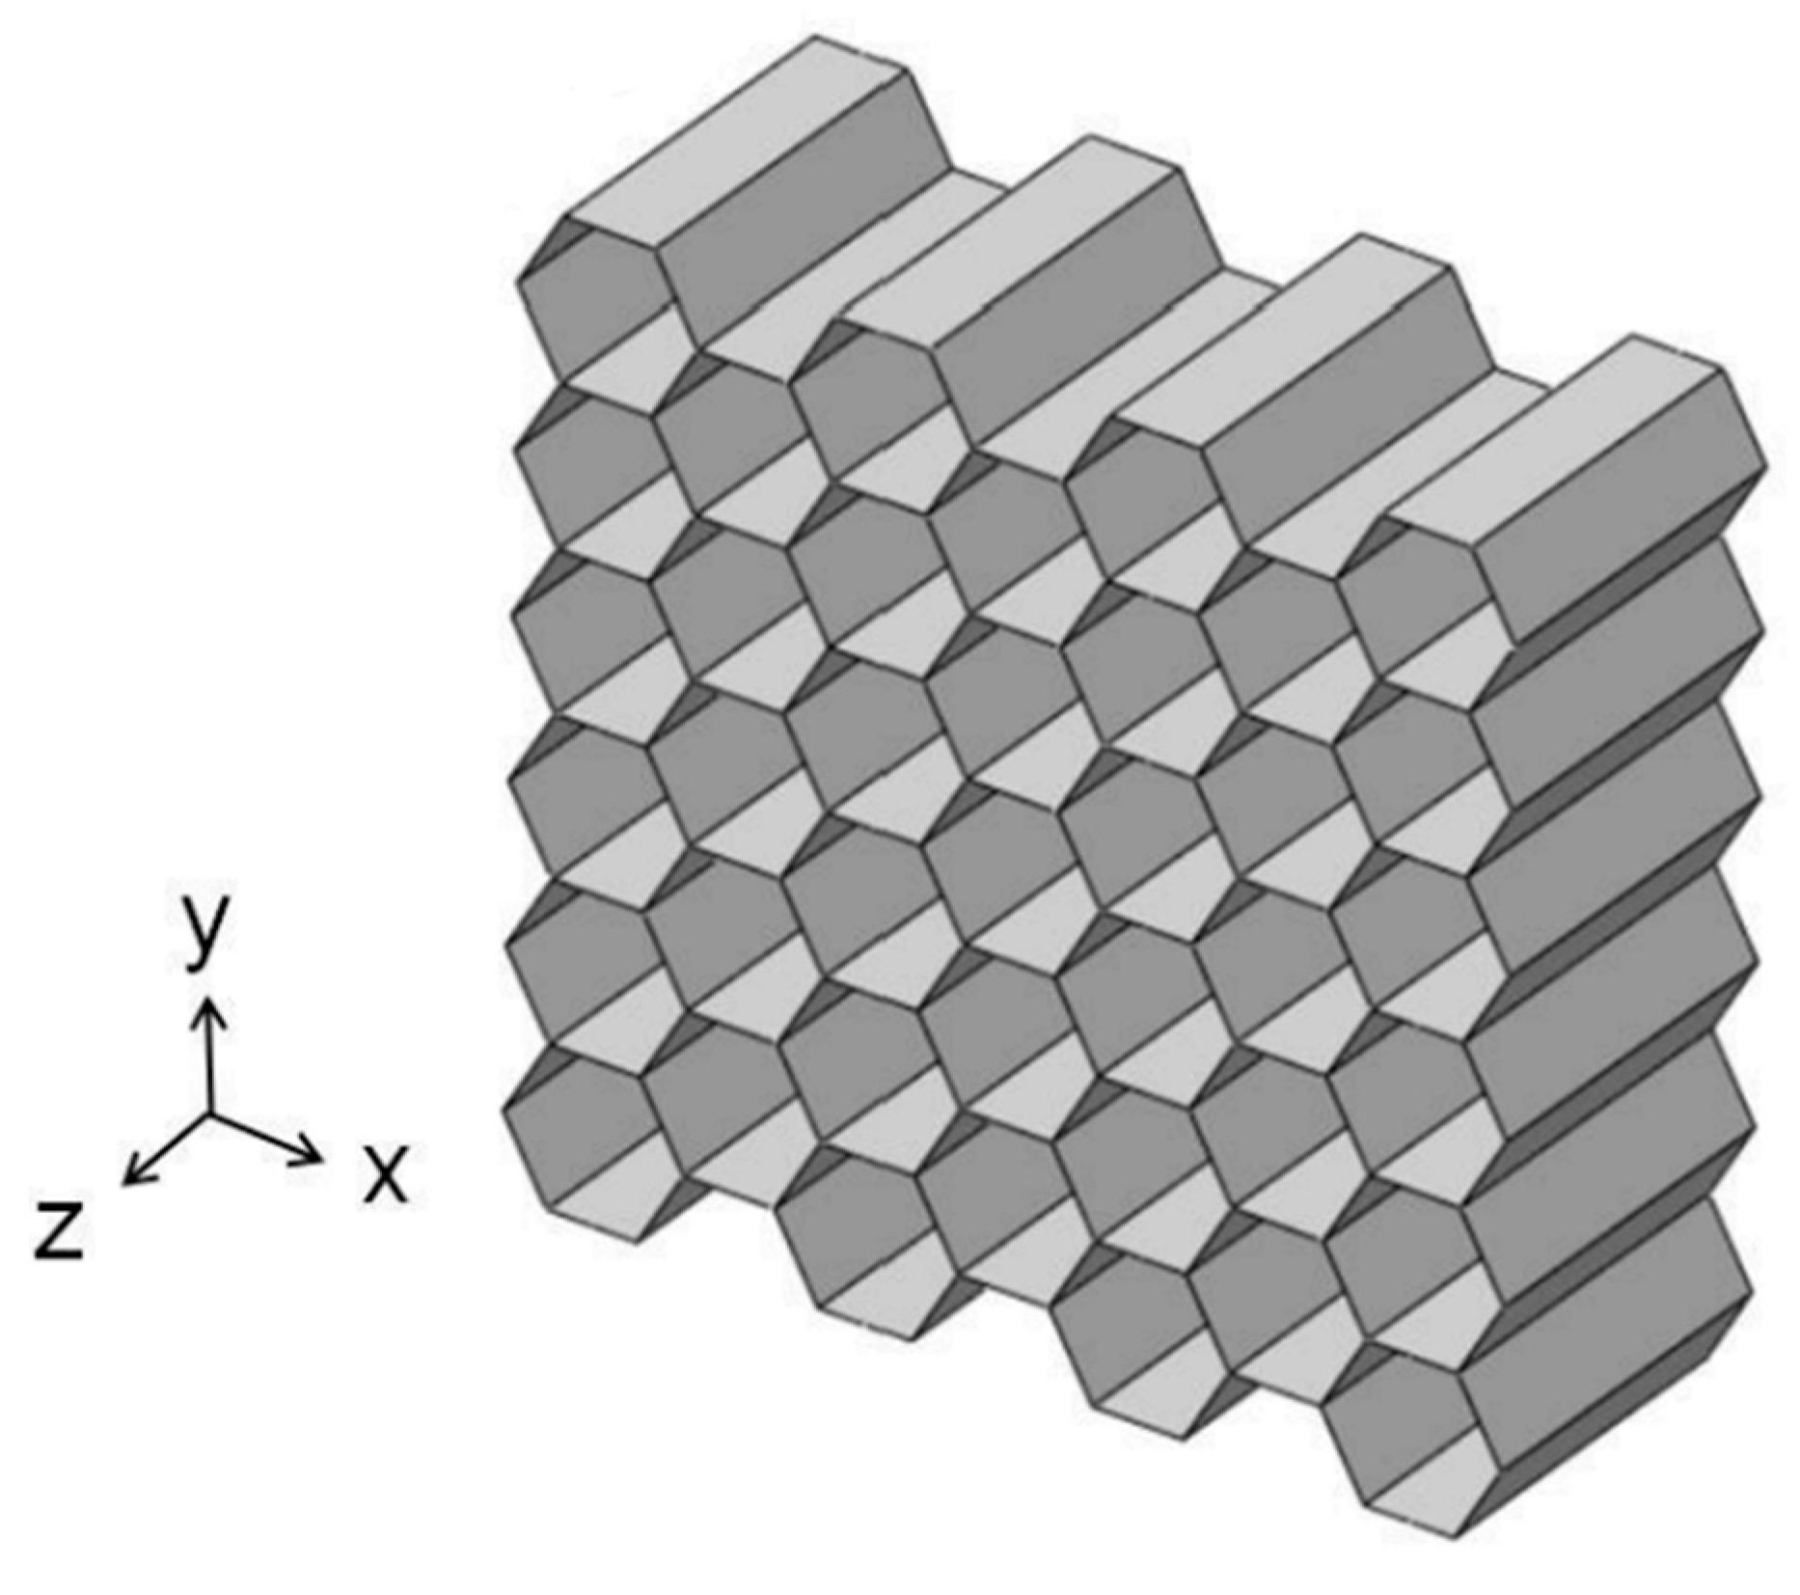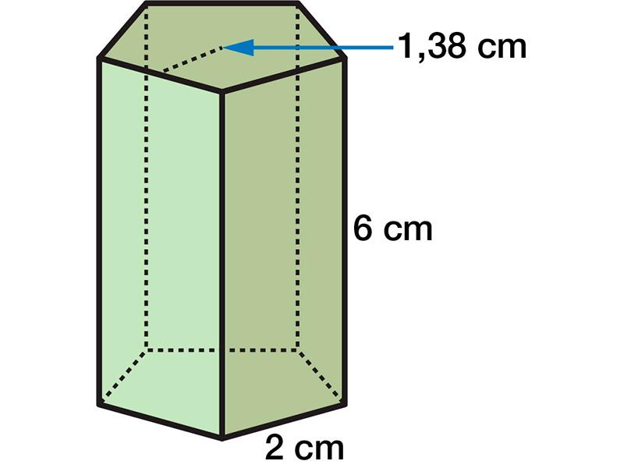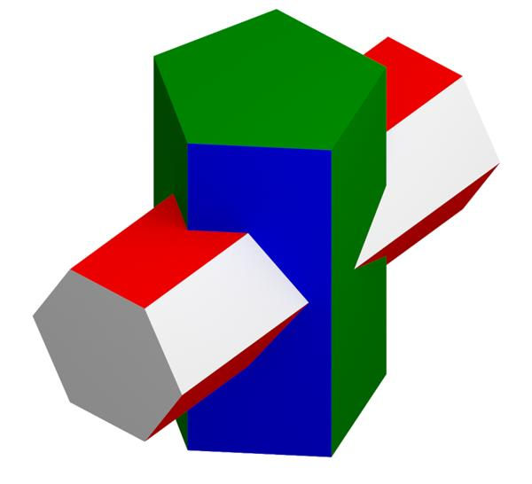
Created by joining two or more hexagonal prisms.
Examples:
- Two hexagonal prisms joined along a lateral face.
- Multiple hexagonal prisms arranged side by side.
- Hexagonal prism combined with a rectangular prism.
- Hexagonal prism joined to a triangular prism.
- Composite solid formed by stacking hexagonal prisms.
- Multiple hexagonal prisms joined end to end.

Mixed-Prism Composite Solids
# Source: AI Source: Provided by: [Data Path: Persons Table -> ID Column: 1, Name_En Column: Motasem Essam] -> From: [ChatGPT] on [7/25/2026]
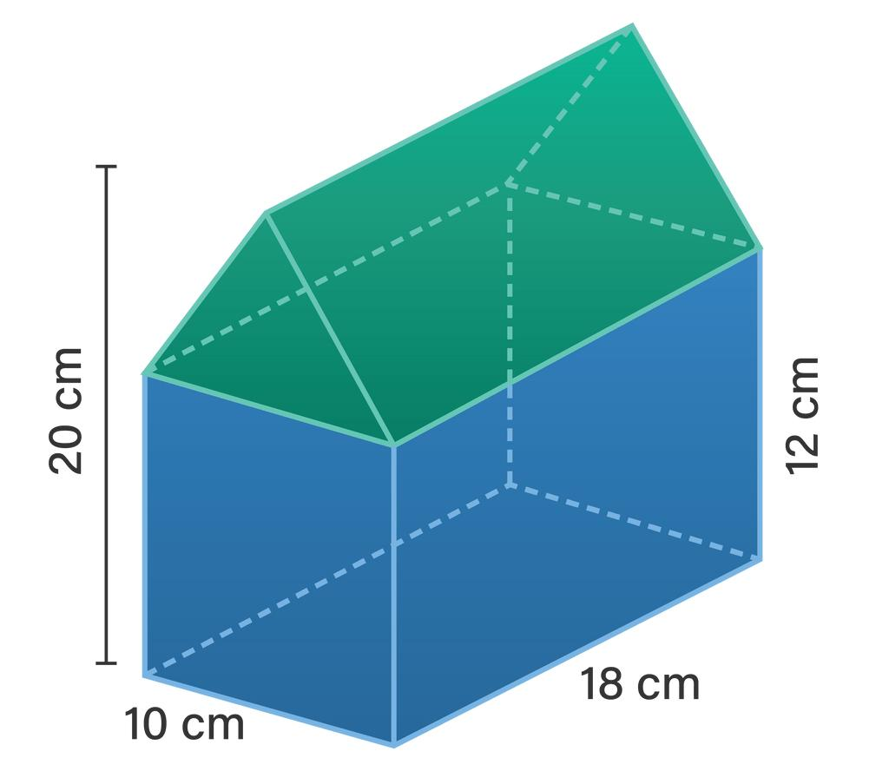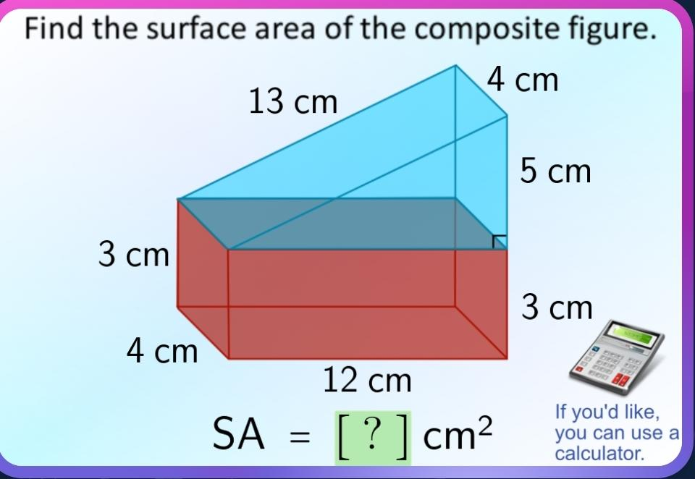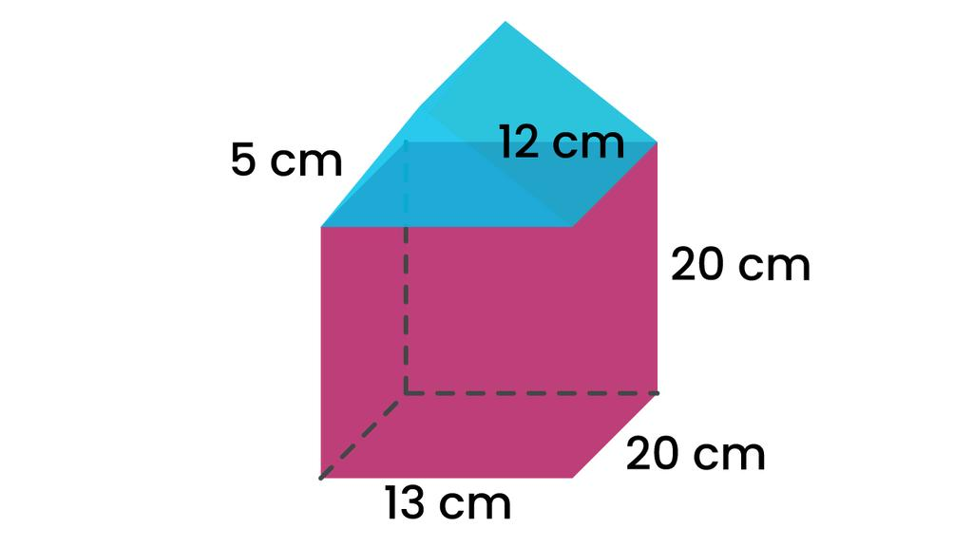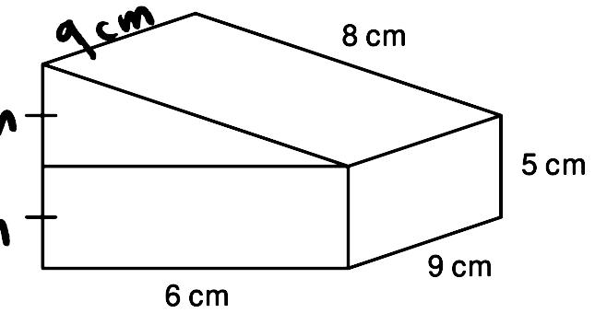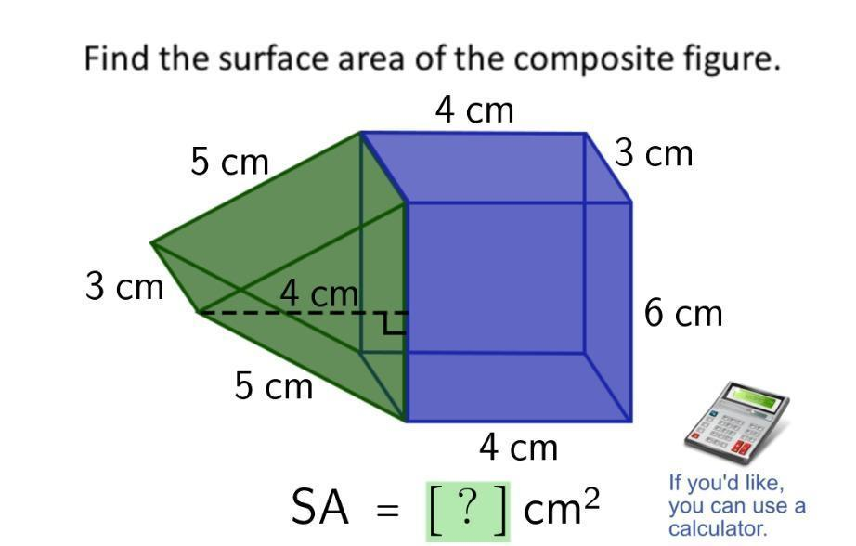
Created by joining two or more prisms with different polygonal base shapes.
Examples:
- Rectangular prism combined with a triangular prism.
- Rectangular prism combined with a pentagonal prism.
- Triangular prism combined with a hexagonal prism.
- Square prism combined with a triangular prism.
- Rectangular prism combined with triangular and pentagonal prisms.
- Composite solid formed by joining several different types of prisms.

Classification by Joining Arrangement
# Source: AI Source: Provided by: [Data Path: Persons Table -> ID Column: 1, Name_En Column: Motasem Essam] -> From: [ChatGPT] on [7/25/2026]
Prism-based composite solids can also be classified according to how their component prisms are connected.
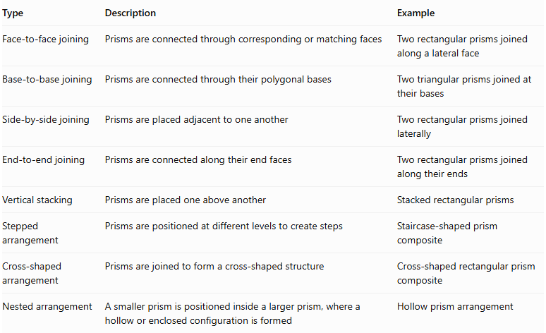
Type | Description | Example
Face-to-face joining | Prisms are connected through corresponding or matching faces | Two rectangular prisms joined along a lateral face
Base-to-base joining | Prisms are connected through their polygonal bases | Two triangular prisms joined at their bases
Side-by-side joining | Prisms are placed adjacent to one another | Two rectangular prisms joined laterally
End-to-end joining | Prisms are connected along their end faces | Two rectangular prisms joined along their ends
Vertical stacking | Prisms are placed one above another | Stacked rectangular prisms
Stepped arrangement | Prisms are positioned at different levels to create steps | Staircase-shaped prism composite
Cross-shaped arrangement | Prisms are joined to form a cross-shaped structure | Cross-shaped rectangular prism composite
Nested arrangement | A smaller prism is positioned inside a larger prism, where a hollow or enclosed configuration is formed | Hollow prism arrangement

Classification by Component Similarity
# Source: AI Source: Provided by: [Data Path: Persons Table -> ID Column: 1, Name_En Column: Motasem Essam] -> From: [ChatGPT] on [7/25/2026]
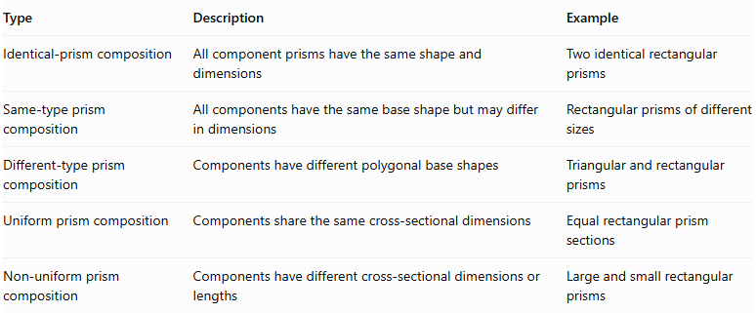
Type | Description | Example
Identical-prism composition | All component prisms have the same shape and dimensions | Two identical rectangular prisms
Same-type prism composition | All components have the same base shape but may differ in dimensions | Rectangular prisms of different sizes
Different-type prism composition | Components have different polygonal base shapes | Triangular and rectangular prisms
Uniform prism composition | Components share the same cross-sectional dimensions | Equal rectangular prism sections
Non-uniform prism composition | Components have different cross-sectional dimensions or lengths | Large and small rectangular prisms

Mathematical Properties and Formulas

Total Volume
# Source: AI Source: Provided by: [Data Path: Persons Table -> ID Column: 1, Name_En Column: Motasem Essam] -> From: [ChatGPT] on [7/25/2026]
The volume of a prism-based composite solid is calculated by adding the volumes of its individual prism components.
For two prisms:
$$\boxed{V_{total}=V_{1}+V_{2}}$$
For multiple non-overlapping components:
$$\boxed{V_{total}=\sum_{i=1}^{n}{V_{i}}}$$
Where:
- $V_{total}$: Total volume of the composite solid.
- $V_{i}$: Volume of each prism component.
- $n$: Number of prism components.

Volume of Common Prism Components
# Source: AI Source: Provided by: [Data Path: Persons Table -> ID Column: 1, Name_En Column: Motasem Essam] -> From: [ChatGPT] on [7/25/2026]
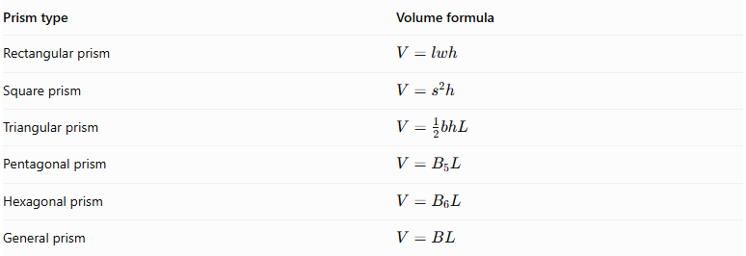
Prism type | Volume formula
Rectangular prism | $$V=lwh$$
Square prism | $$V=s^{2}h$$
Triangular prism | $$V=\frac{1}{2}bhL$$
Pentagonal prism | $$V=B_{5}L$$
Hexagonal prism | $$V=B_{6}L$$
General prism | $$V=BL$$
Where:
- $B$: Area of the polygonal base.
- $L$: Length or perpendicular distance between the bases.
- $l$: Length of a rectangular base.
- $w$: Width of a rectangular base.
- $h$: Height of a prism or triangle, as applicable.
- $s$: Side length of a square base.

External Surface Area
# Source: AI Source: Provided by: [Data Path: Persons Table -> ID Column: 1, Name_En Column: Motasem Essam] -> From: [ChatGPT] on [7/25/2026]
The external surface area is the sum of all exposed faces of the component prisms after they are joined.
For two prisms joined along a common face:
$$\boxed{{SA}_{total}={SA}_{1}+{SA}_{2}-2A_{contact}}$$
For multiple prisms joined through flat contact faces:
$$\boxed{{SA}_{total}=\sum_{i=1}^{n}{{SA}_{i}}-2\sum_{j=1}^{m}{A_{j}}}$$
Where:
- ${SA}_{i}$: Total surface area of each separate prism.
- $A_{j}$: Area of each internal joining interface.
- $m$: Number of joining interfaces.
Important: Internal contact surfaces are counted twice when calculating the separate surface areas of the components. Therefore, their combined area must be subtracted.

Worked Examples

Example 1: Two Rectangular Prisms Joined Side by Side
# Source: AI Source: Provided by: [Data Path: Persons Table -> ID Column: 1, Name_En Column: Motasem Essam] -> From: [ChatGPT] on [7/25/2026]
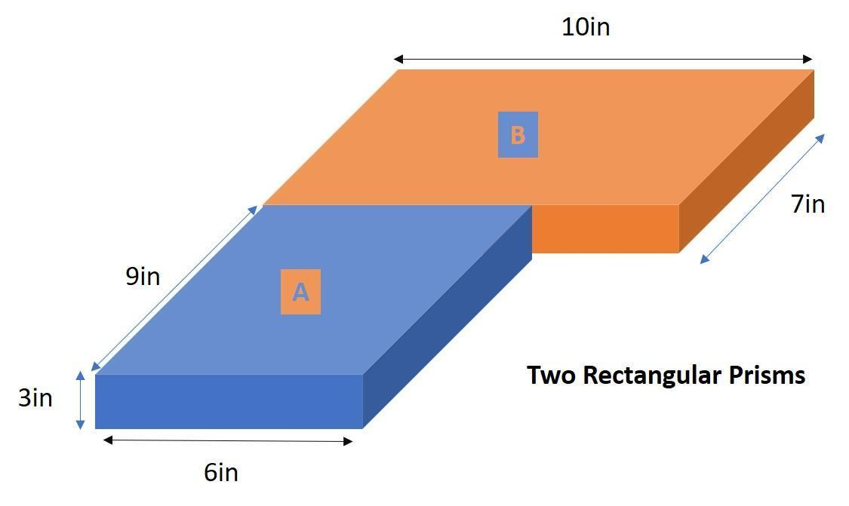
Two rectangular prisms are joined along one rectangular face to form a larger rectangular prism.
Given:
First prism:
- Length: $l_{1}=8 cm$
- Width: $w_{1}=4 cm$
- Height: $h_{1}=3 cm$
Second prism:
- Length: $l_{2}=4 cm$
- Width: $w_{2}=4 cm$
- Height: $h_{2}=3 cm$
Step 1: Calculate the volume of the first prism
$$V_{1}=l_{1}w_{1}h_{1}$$
$$V_{1}=8(4)(3)=96{ cm}^{3}$$
Step 2: Calculate the volume of the second prism
$$V_{2}=l_{2}w_{2}h_{2}$$
$$V_{2}=4(4)(3)=48{ cm}^{3}$$
Step 3: Calculate the total volume
$$V_{total}=V_{1}+V_{2}$$
$$V_{total}=96+48$$
$$\boxed{V_{total}=144{ cm}^{3}}$$
Step 4: Calculate the external surface area
The joining face has dimensions $4×3$.
$$A_{contact}=4(3)=12{ cm}^{2}$$
Surface area of the first prism:
$${SA}_{1}=2(8(4)+8(3)+4(3))$$
$${SA}_{1}=136{ cm}^{2}$$
Surface area of the second prism:
$${SA}_{2}=2(4(4)+4(3)+4(3))$$
$${SA}_{2}=80{ cm}^{2}$$
Subtract the two internal contact surfaces:
$${SA}_{total}={SA}_{1}+{SA}_{2}-2A_{contact}$$
$${SA}_{total}=136+80-24$$
$$\boxed{{SA}_{total}=192{ cm}^{2}}$$

Example 2: Rectangular Prism Combined with a Triangular Prism
# Source: AI Source: Provided by: [Data Path: Persons Table -> ID Column: 1, Name_En Column: Motasem Essam] -> From: [ChatGPT] on [7/25/2026]
A triangular prism is joined to a rectangular prism to create a composite solid.
Given:
Rectangular prism:
- Length: $L=10 cm$
- Width: $w=6 cm$
- Height: $h=4 cm$
Triangular prism:
- Triangular base: $b=6 cm$
- Triangle height: $t=3 cm$
- Prism length: $L=10 cm$
Step 1: Calculate the rectangular prism volume
$$V_{1}=Lwh$$
$$V_{1}=10(6)(4)=240{ cm}^{3}$$
Step 2: Calculate the triangular prism volume
$$V_{2}=\frac{1}{2}btL$$
$$V_{2}=\frac{1}{2}(6)(3)(10)$$
$$V_{2}=90{ cm}^{3}$$
Step 3: Calculate the total volume
$$V_{total}=240+90$$
$$\boxed{V_{total}=330{ cm}^{3}}$$

Important Characteristics
# Source: AI Source: Provided by: [Data Path: Persons Table -> ID Column: 1, Name_En Column: Motasem Essam] -> From: [ChatGPT] on [7/25/2026]
- Formed by joining two or more prism-shaped components.
- Component prisms may have identical or different polygonal bases.
- Prisms may have different dimensions and lengths.
- Components can be joined along their bases or lateral faces.
- The resulting solid may have regular or irregular external boundaries.
- Common arrangements include stacked, stepped, cross-shaped, and side-by-side configurations.
- Total volume is calculated by adding the component volumes when their interiors do not overlap.
- External surface area includes only exposed faces.
- Internal joining faces must be excluded from external surface area calculations.

Comparison with Other Types of Composite Solids Formed by Addition
# Source: AI Source: Provided by: [Data Path: Persons Table -> ID Column: 1, Name_En Column: Motasem Essam] -> From: [ChatGPT] on [7/25/2026]
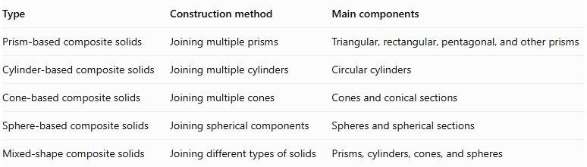
Type | Construction method | Main components
Prism-based composite solids | Joining multiple prisms | Triangular, rectangular, pentagonal, and other prisms
Cylinder-based composite solids | Joining multiple cylinders | Circular cylinders
Cone-based composite solids | Joining multiple cones | Cones and conical sections
Sphere-based composite solids | Joining spherical components | Spheres and spherical sections
Mixed-shape composite solids | Joining different types of solids | Prisms, cylinders, cones, and spheres

Applications
# Source: AI Source: Provided by: [Data Path: Persons Table -> ID Column: 1, Name_En Column: Motasem Essam] -> From: [ChatGPT] on [7/25/2026]
- Architecture: Designing buildings, stepped structures, walls, and structural blocks.
- Construction: Creating foundations, platforms, columns, and layered structures.
- Mechanical engineering: Designing machine components and structural assemblies.
- Manufacturing: Producing objects from joined prismatic components.
- Product design: Creating rectangular housings, modular products, and geometric structures.
- Computer-aided design (CAD): Constructing complex 3D models by combining basic prism shapes.

Key Points
# Source: AI Source: Provided by: [Data Path: Persons Table -> ID Column: 1, Name_En Column: Motasem Essam] -> From: [ChatGPT] on [7/25/2026]
- Prism-based composite solids are formed by joining two or more prisms.
- Their components may have identical or different polygonal bases.
- Common prism components include triangular, rectangular, square, pentagonal, and hexagonal prisms.
- Joining arrangements include face-to-face, base-to-base, side-by-side, and stacked configurations.
- Total volume is calculated by adding the volumes of the component prisms.
- External surface area is calculated using only exposed faces.
- Internal joining surfaces must be excluded from the final surface area.

Conclusion
# Source: AI Source: Provided by: [Data Path: Persons Table -> ID Column: 1, Name_En Column: Motasem Essam] -> From: [ChatGPT] on [7/25/2026]
Prism-based composite solids are three-dimensional geometric objects formed by joining two or more prisms into a single structure. Their components may have different polygonal bases, dimensions, and arrangements. They are useful for studying composite volume and surface area calculations and have practical applications in architecture, construction, engineering, manufacturing, and computer-aided design.

